DX Code Of Conduct

(what you can do to improve DXEtiquette)

DX Code of Conduct
Click on a topic to see more information
I will listen, and listen, and then listen again before calling.
I will only call if I can copy the DX station properly.
I will not trust the DX cluster and will be sure of the DX station's call sign before calling.
I will not interfere with the DX station nor anyone calling and will never tune up on the DX frequency or in the QSX slot.
I will wait for the DX station to end a contact before I call.
I will always send my full call sign.
I will call and then listen for a reasonable interval. I will not call continuously.
I will not transmit when the DX operator calls another call sign, not mine.
I will not transmit when the DX operator queries a call sign not like mine.
I will not transmit when the DX station requests geographic areas other than mine.
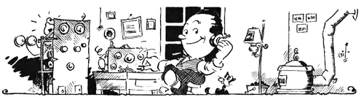

#1 I will listen, and listen and then listen again before calling.
This seems so obvious but it is the most vital thing to do. Careful listening rather than rushing to transmit will get the DX into your log. You must listen to find out whether the DX is working split and if so, where is he listening? Then you need to listen to the calling stations in order to determine what the DX station is doing. For example, he may be working gradually up or down the pile-up frequency range – and you need to find the best spot to call. And it may be time to ask yourself: “Do I really need to work this bit of DX, right now? Can I wait a while for the pile-up to subside?”

#2 I will only call if I can copy the DX station properly.
You also need to listen carefully to determine how well you can hear the DX station to be sure you will hear his reply to your call and to avoid causing interference by transmitting at the wrong time. It is extremely frustrating for a DX station to return a call to a station that is unable to hear him, thereby causing incessant QRM.

#3 I will not trust the Cluster and will be sure of the DX station’s callsign before calling.
Cluster spots often show the wrong call sign. Before you log a station, you should hear the station’s callsign on the air – don’t trust spotting networks. The DX operator should send his call sign at regular intervals. Unfortunately, not all operators do this!
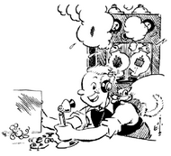

#4 I will not interfere with the DX station or anyone calling and will never tune up on the
DX frequency or in the QSX slot.
Sadly, this covers a multitude of operators, employing poor operating practices. We are frequently afflicted with “Policemen,” people who repeatedly jump in to tell callers that “the DX is listening up” – often adding a gratuitous insult. The rule is quite simple: never, ever transmit on the DX frequency for any purpose whatsoever.
I will pay attention to the operator's instructions if he is operating "split" so as to stay in his preferred bandwidth.

#5 I will wait for the DX station to end a contact before calling.
If you transmit before a QSO is over, you are likely to interfere with the exchange of information, lengthening the QSO and slowing the process. It may seem clever to “nip in” as the previous contact is ending but many DX stations don’t like it, as such operating may break the pattern of the operator, which is what helps everyone to know when to transmit.
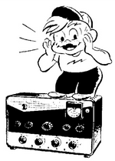

#6 I will always send my full call sign.
This is essential for CW and SSB, because incomplete calls lead to an extra transmission, slowing the operator’s progress with the pileup. If the operator is responding to partial call signs, it may appear that you should call with only several letters. Generally, this is not the case. Always use your full call sign.

#7 I will call and then listen for a reasonable interval. I will not call continuously.
Continuous calling is selfish and arrogant. With a computer or memory keyer, it is easy to send continuously. Unfortunately, it prevents you from listening and knowing what is taking place. In addition, it raises the QRM floor greatly, making life difficult for the DX station and everyone else.
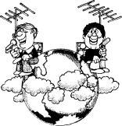

#8 I will not transmit when the DX operator calls another callsign, not mine.
Perhaps this is intuitively obvious, but it is a common occurrence. If it is clear that the station is not calling you, do not transmit.

#9 I will not transmit when the DX Operator queries a call sign, not like mine.
In life outside amateur radio it would simply be considered rude to answer when someone else is asked a question! How do you know if the station is calling you? Perhaps the DX operator has a partial version of your call. Is it me? “The timing is right!” Yes, the timing may seem right, but it may also be “right” for many other stations. If the DX is actually calling you and hears nothing, he will call you again. Then you can call. Only one letter from your call sign is NOT enough, however. Calling when not being addressed raises the floor level of QRM and slows progress dramatically.
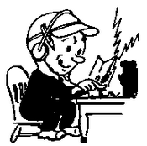

#10 I will not transmit when the DX operator requests geographic areas other than mine.
You must recognize and accept that when an operator is calling for a specific geographic area (e.g. NA for North America, AS for Asia), you must not call until the operator’s instructions change. Even if his choice appears incorrect, you must follow his instructions. The DX operator is in control. Here’s an important point: If a DX operator is working, some area, perhaps North America, and he fails to say so between QSOs, do not begin calling immediately. Call only when it is clear that the operator’s instructions have changed. To do otherwise is impolite and simply slows the process.

#11 When the DX operator calls me, I will not repeat my callsign unless I think he has copied it incorrectly.
If you repeat your call sign, the DX station may think that he has your call sign wrong. He might then listen very carefully – again – thus slowing the process. A DX operator will generally log what he has if you say nothing further.
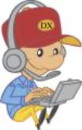

#12 I will be thankful if and when I do make a contact.
There should certainly be a pride of accomplishment when you get a QSO with a guy in a far-away entity. But before you start basking in the glow of accomplishment, think about the help you received from your partners, perhaps Mr. Icom, Mr. Alpha, and Mr. Force 12. If your ego still feels a need to take ALL the credit, try again. But this time turn off your amplifier and connect your rig barefoot to a dipole. If you get through the pile up this time, then YOU, as the operator, can take more of the credit.
You should also acknowledge that you would not have had the contact without the skill of the operator at the other end who undoubtedly made sacrifices to be there for you. So be thankful for all this help you received.

#13 I will respect my fellow hams and conduct myself so as to earn their respect.
Respect is about behaving well toward others. DXing is very competitive. If you operate otherwise, you may acquire a bad reputation. DXing will be the most fun for everyone if we all behave with politeness, mutual respect and even a bit of humility!

